Usage

The clock is designed to be viewed from the panel, or any browser on the network. To access the screen remotely, use the url http:://<ip>:8081. On my network, this is http://192.168.1.118:8081

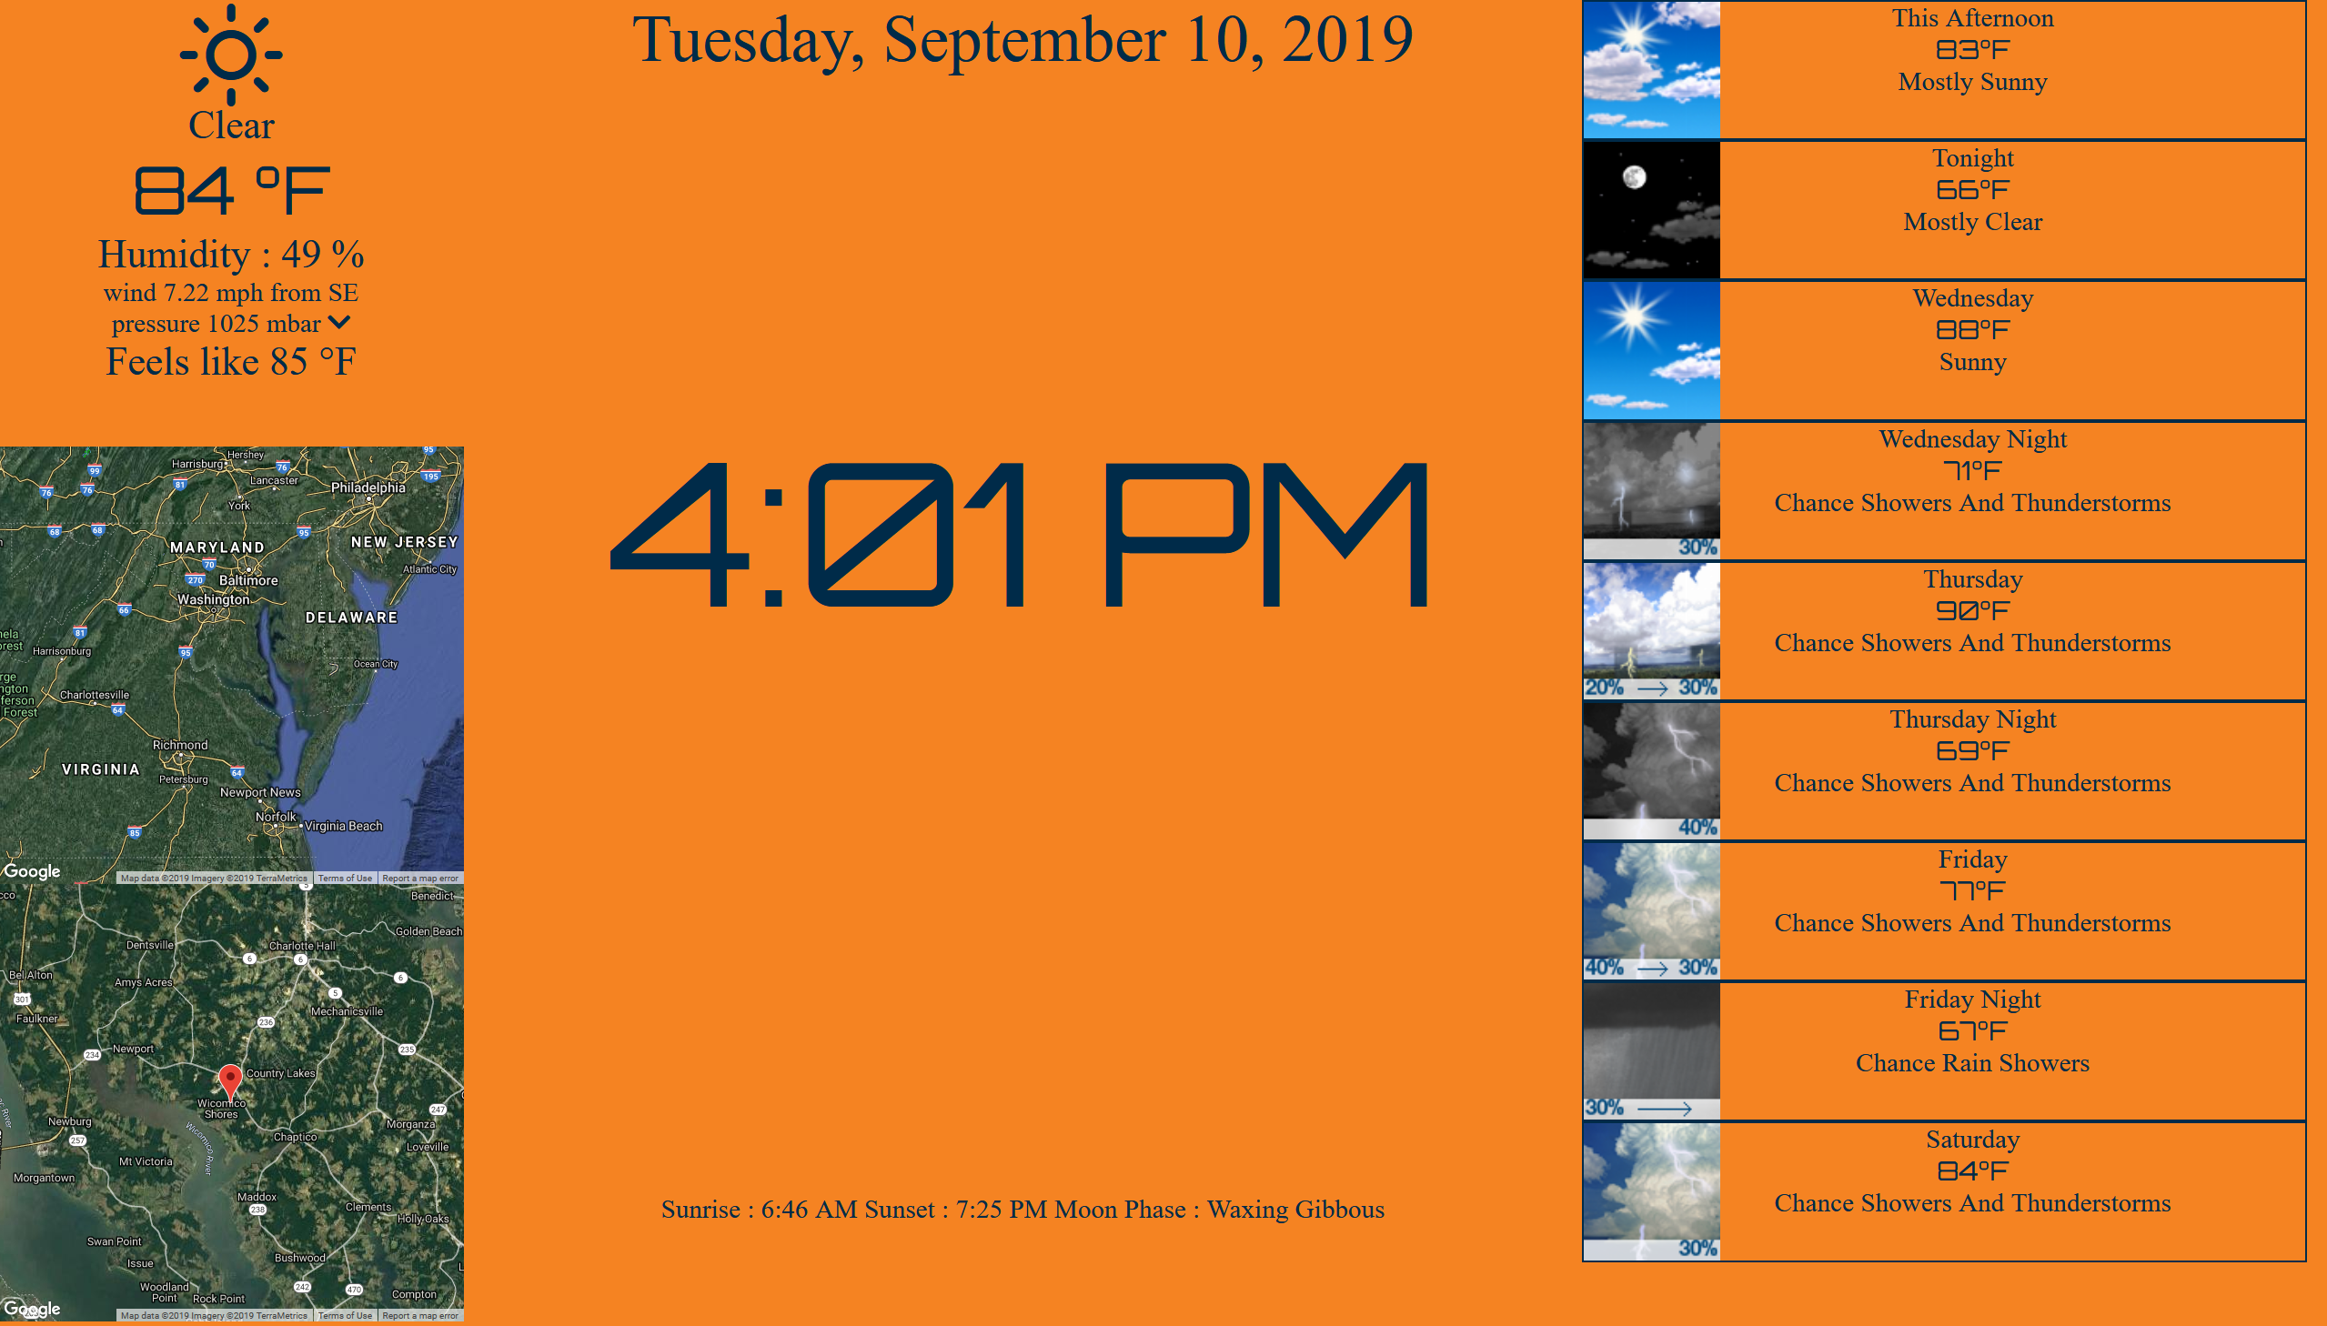

Upper Left : DarkSky current observations. Updates every 2 minutes.

Lower Left : US National Weather Service radar. 20 Minute loop grabbing frames every 5 Minutes.

Upper Center : Today’s day

Middle Center : Current time

Lower Center : Sunrise/Sunset times and moon phase

Full Right : 9 forecast intervals as provided by National Weather Service

Clicking on the upper left block, containing the current observations brings up a graph of the last 48 hours readings of temperature / pressure / and humidity. Values reset when the clock is rebooted since they are stored in RAM and not written to disk.

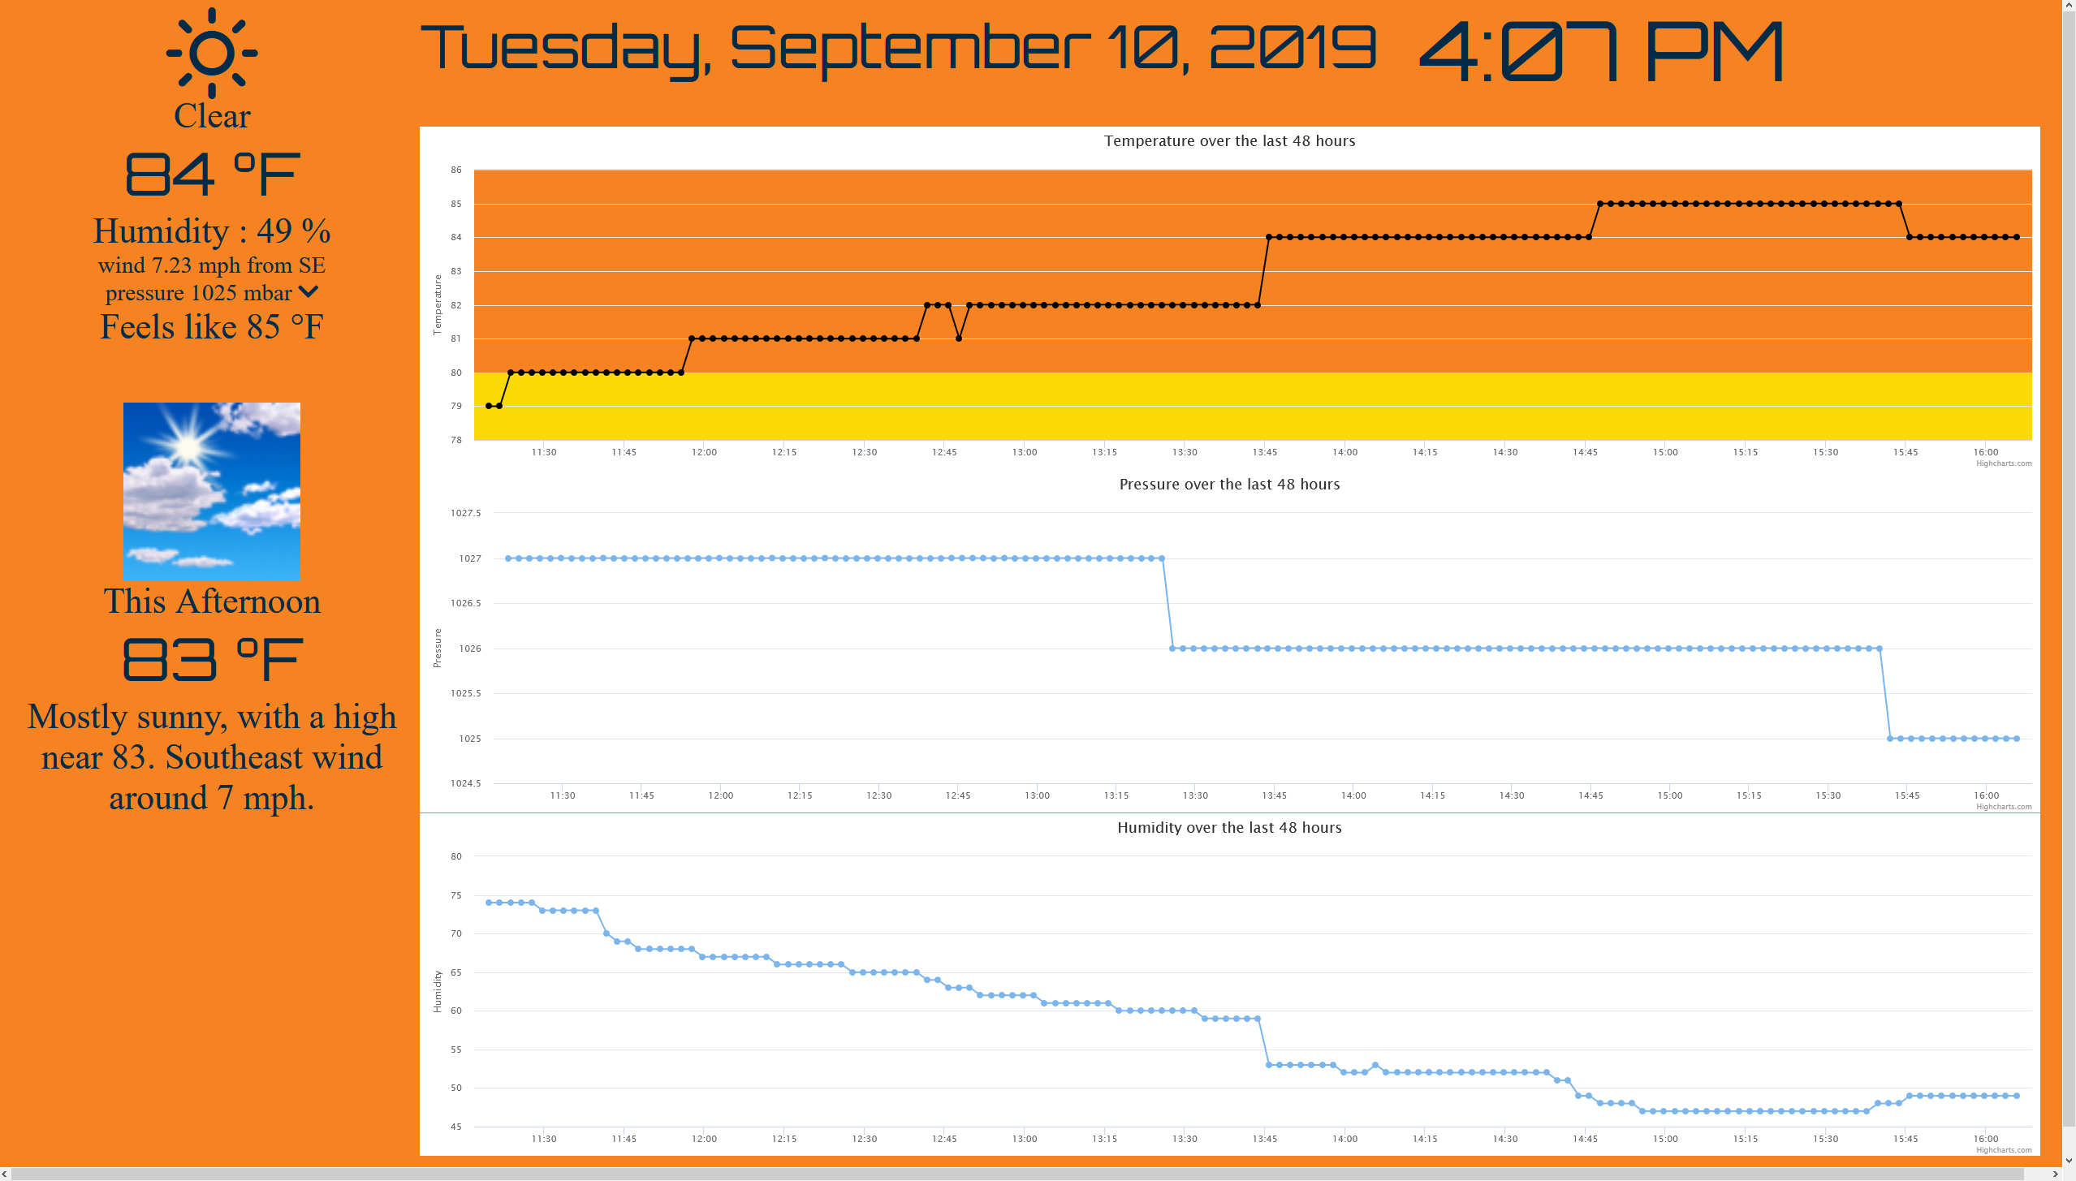

Clicking any where on the screen returns you to the main page.

Clicking on either radar images brings you to the radar zoom page

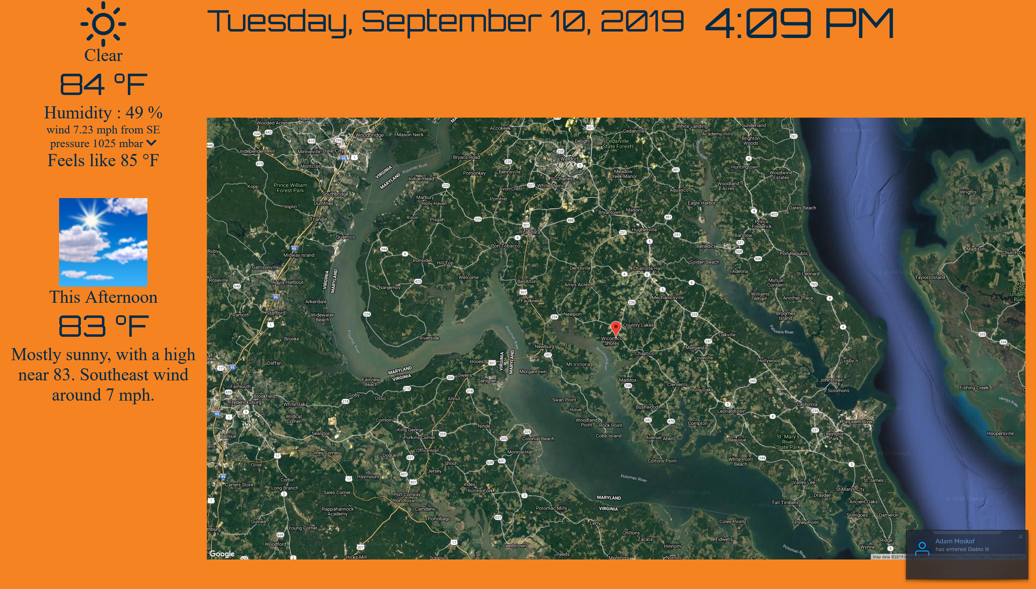

Clicking anywhere on the screen returns you to the main screen.

Clicking on the moon phase brings up the current moon image at the US Naval Observatory

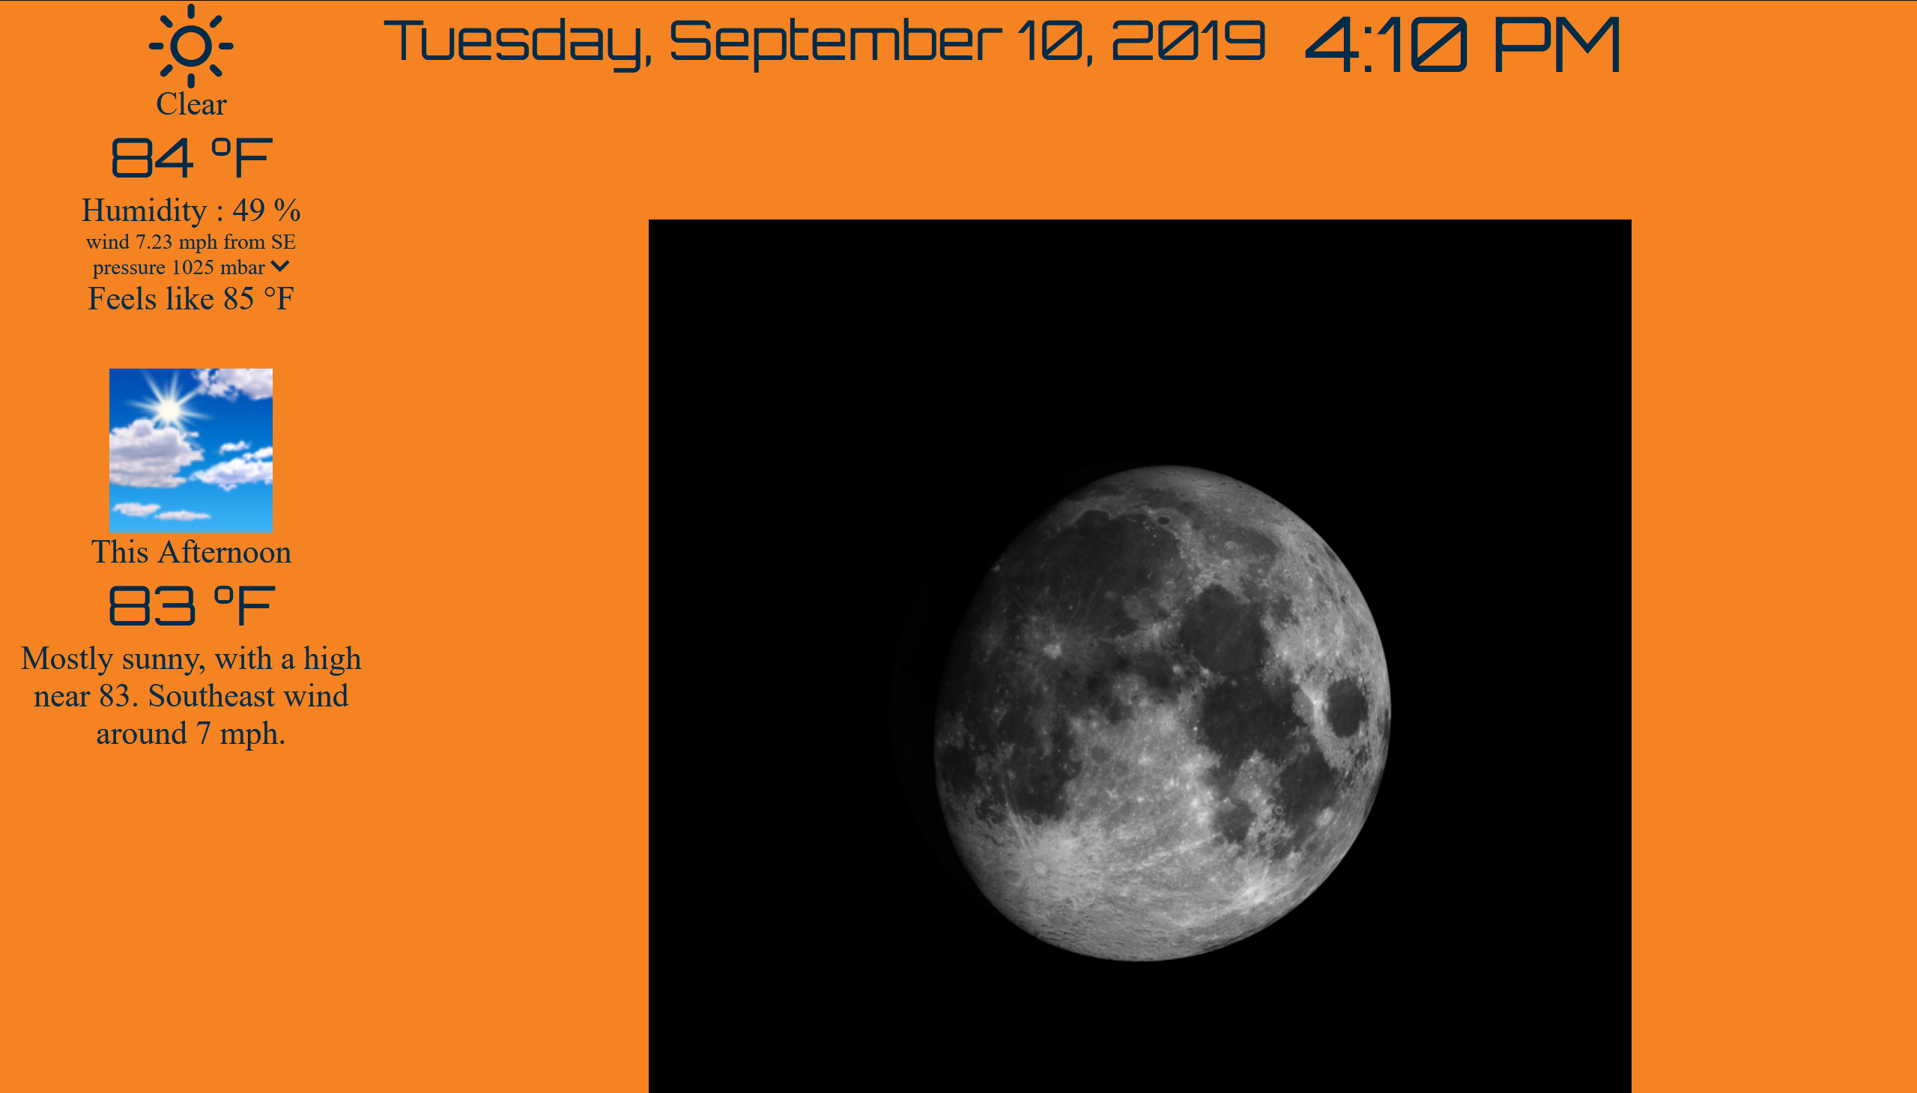

Clicking anywhere on the screen returns you to the main screen.

Clicking on the forecast block brings up the forecast detail page

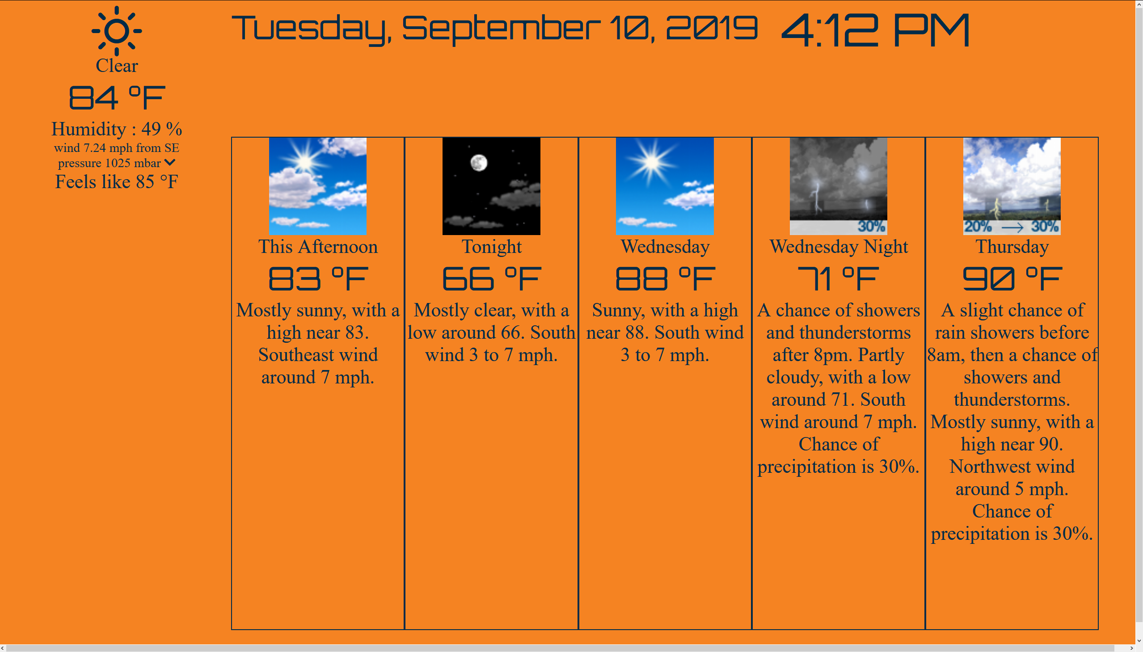

Clicking anywhere on the screen returns you to the main page.

Clicking on any other part of the screen puts the clock in “night mode”

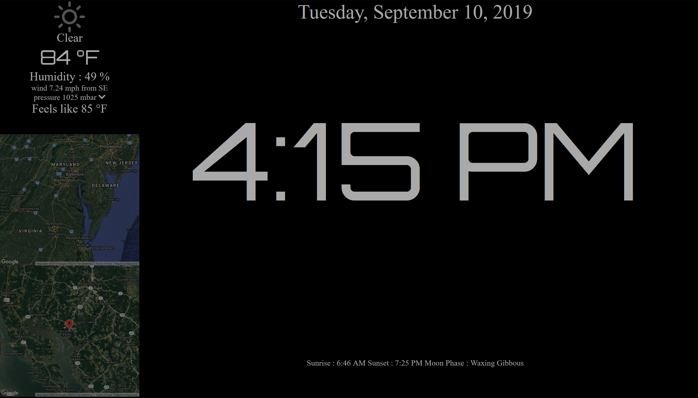

Clicking anywhere on the clock should put it back into “normal” mode.